**Visual Treatment / Look Book**

***Inspirations and Influences***

One of the first things that appear in my film is the painting “The Luncheon on the Grass” by a French painter Edouard Manet, which depicts a female nude and a scantily dressed female bather on a picnic with two fully dressed men in a rural setting in France. Since my film directly addresses issues around sexism, ageism, representation of women in the media and beauty standards that impose restrictions and control over women’s bodies on a daily basis, I drew inspiration for my project from various entertainment outlets such as art exhibitions, television shows, advertisements, fashion magazines, and toys (Barbie dolls and paper dolls are just a few examples that will appear in my piece). My film is the experimental disposition of narrated images that relies heavily on visual content, but every shot has its purpose.

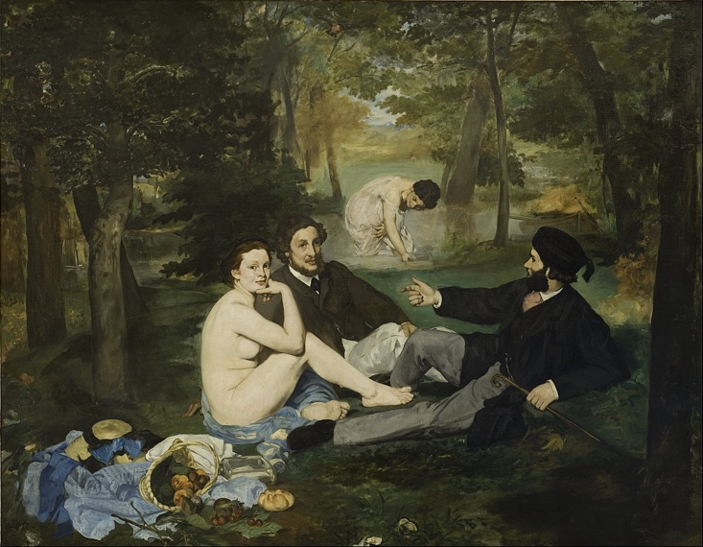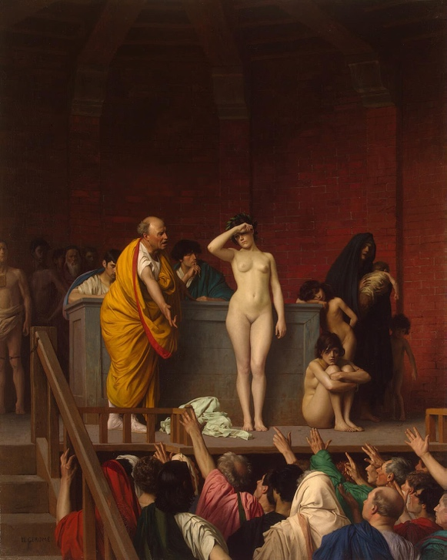

*(Left) “Le Dejeuner sur l'herbe” (The Luncheon on the Grass) by Edouard Manet, 1863;*

*(Right)* “*Le Marche d’esclaves” (The Slave Market) by Jean-Leon Gerome, 1866.*

When it comes to my objects/female actors, I am not striving for perfection; I treat my female actors with respect and dignity, and I want to embrace their little quirks and oddities rather than seeing them as simple desired objects constructed in my fantasy.

As a director, I want to study my characters/subjects with the gentle gaze of my camera, slowly filling the absence rooted in my personal history with a feeling of trust and appreciation for the women that I have on my crew. I want to depict my objects in same fashion as one of my favorite painters, Gustav Klimt, did – he depicted all forms of femininity, including pregnancy, aging and the loss of physical beauty, viewing femininity as a phenomenon of nature rather than an elusive set of certain traits and possessions.

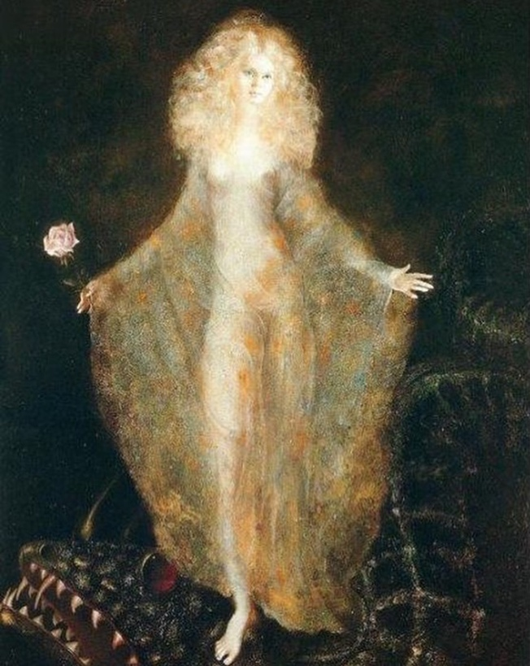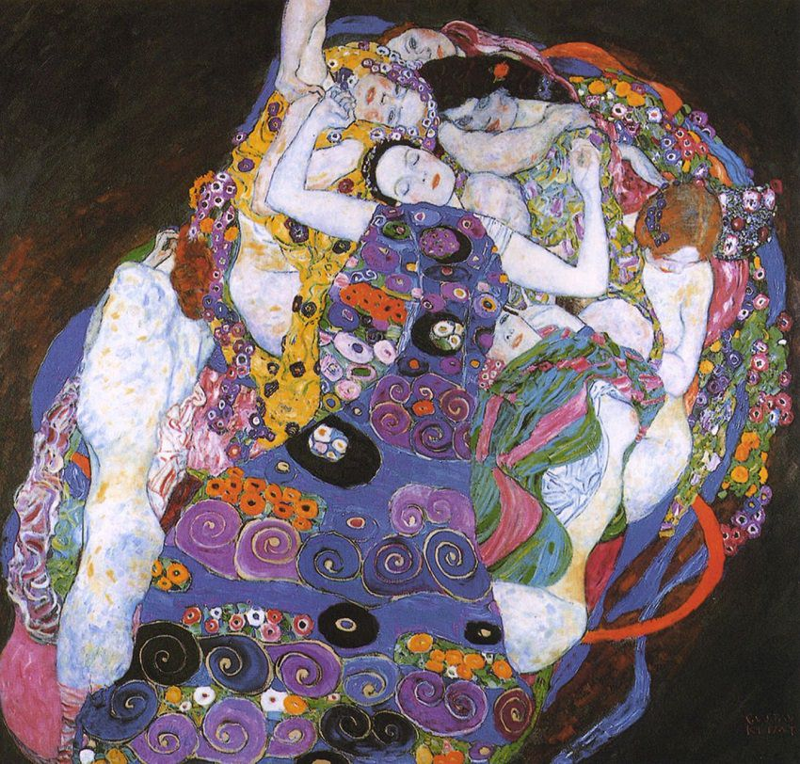

*(Left) “La Passagere” by Leonor Fini; (Right) “Die Jungfrau” by Gustav Klimt*

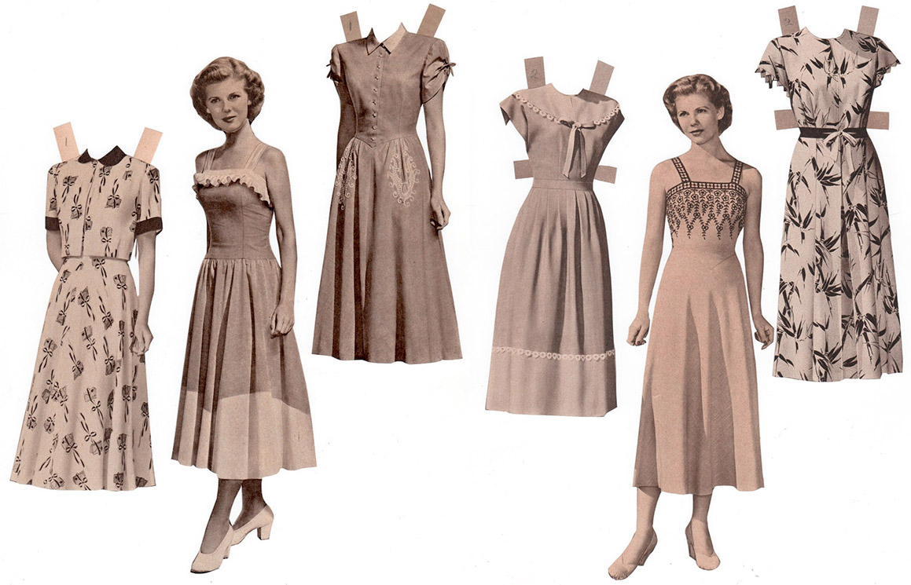

*A series of homemade catalog dolls from the 1940s*

[*https://www.collectorsweekly.com/*](https://www.collectorsweekly.com/)

*Just one of the problematic toys for young girls*

I also drew inspirations from my personal experiences and the stories of my female friends and relatives, as well as from the stories that were shared by women on social media. The resiliency of women never ceases to amaze me. One such example can be seen on that old black and white photo of a Polish woman posing for a photo with the post-war ruins on the background. I decided to pay homage to this particular photo/scene and her inexhaustible optimism in my film and include a similar scene.

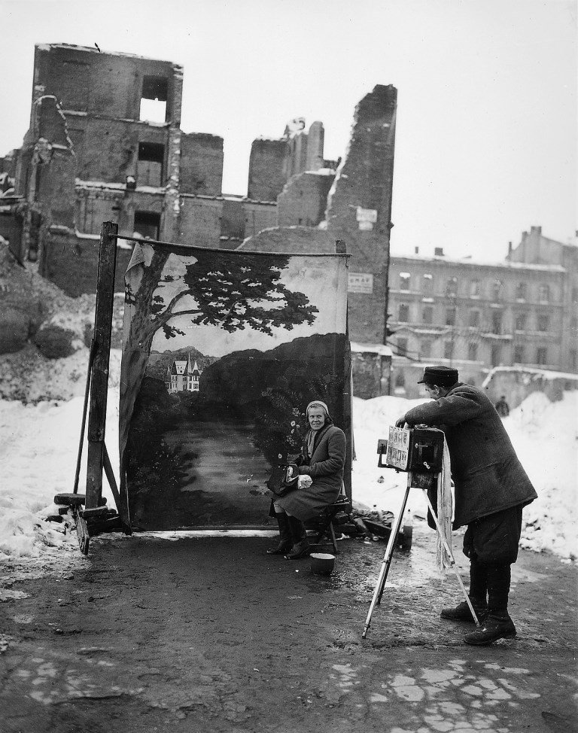

***Light and Color***

The colors used in this story should be warm but dull, with the blues, reddish-browns and dusty red tones for night shots and the orange/warm yellow and soft brown tones for scenes shot during the day. I am striving for the “silk stocking effect” with softer, natural colors, lower contrast, and a bit of grain. My aim is the timeless, nostalgic look of film photography. Some shots in my film are very warm toned with rich, vibrant colors, and others are more subdued, with cooler tones and less saturation, still others are hazy and almost dreamlike.

Natural light and gradient of several colors will be used throughout the film (ex.: yellow, brown, blue).



*Color palette for the film*

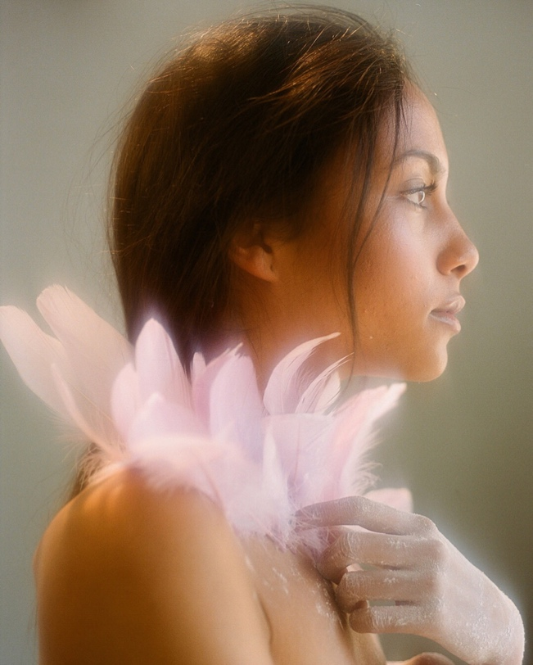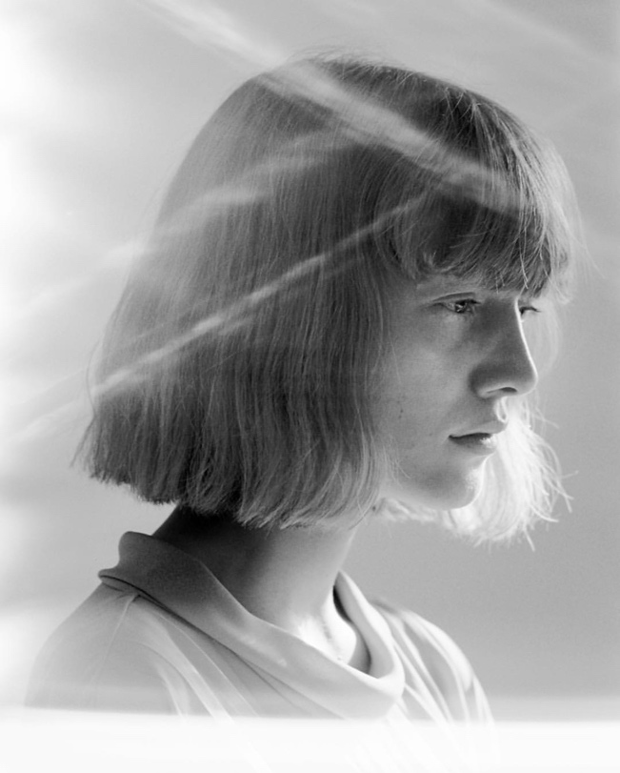

*Soft, dreamlike focus*

*(Left) Photo by Carlota Guerrero; (Right) Photo by Lou Schoof for Union Magazine*

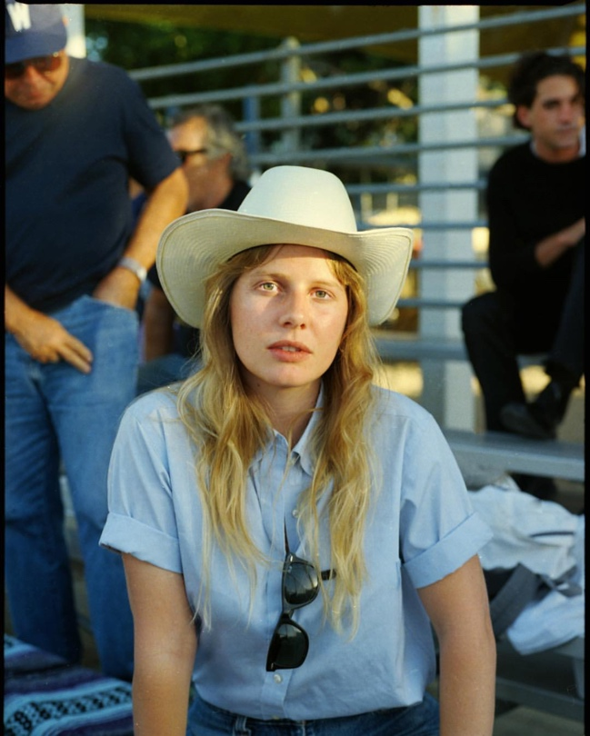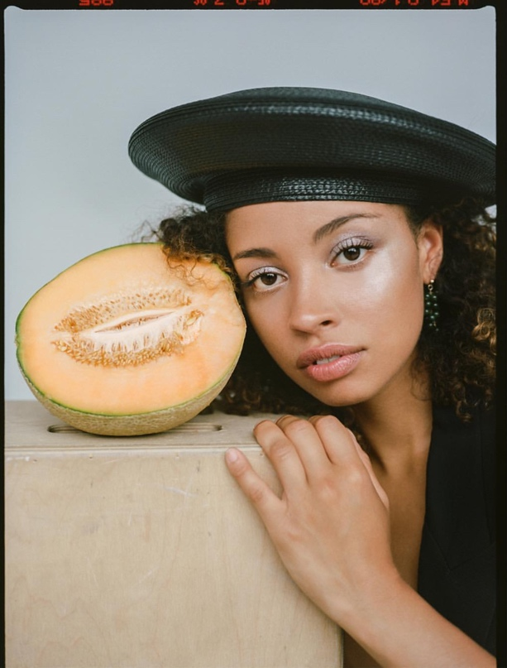

*Some analogue photography by Jacqueline Harriet*

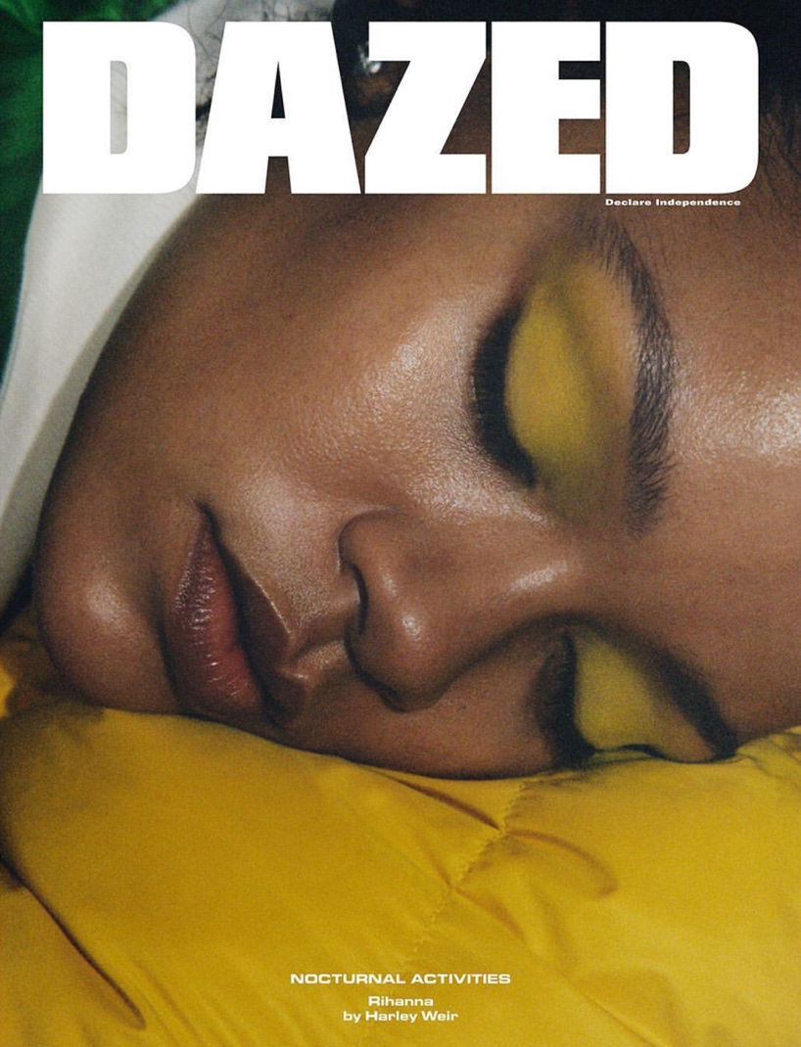

*Warm tones I am striving for*

*(c) Rihanna for Dazed Magazine*

***Sound Design***

My project is the experimental disposition of narrated images that relies heavily on visual content, so there’s absolutely no dialogue in my piece, only voice-over. Thus the sound design for this film is mostly non-diegetic, as it comprised of sound effects (wind blowing through trees, the reflection of sound waves from a surface back to the listener), voice-over, and some ambient instrumental music.

***Style and Composition***

I would like to use a screen ratio of 1.37:1 or 1.85:1 as character-driven scenes might call for a taller ratio to make close-ups more naturalistic. Close-up shots allow the viewer to experience an intimate connection with the characters and make a statement through the intrusion into their personal space.

***Camera Motion***

The camera motion in my film is mostly emotionally motivated. The camera should move from medium shots to close up shots to long shots to establish the scene and its elements but also character’s faces, belongings, and props. I am interested in creating an illusion of continuous motion, as if the camera constantly moves through the scene and pauses to gaze or linger on characters (ex.: *Go Fish* (1994), Garland Jeffreys’ “*Hail Hail Rock 'n' Roll*.”) Medium shots and close-ups will convey the intimate, but detached presence in the action.